Supporters Certificate

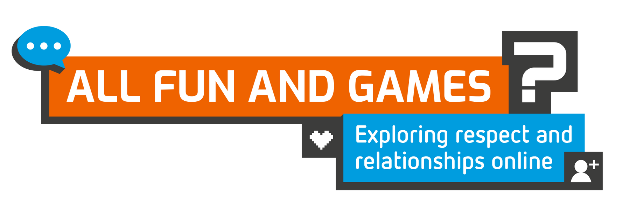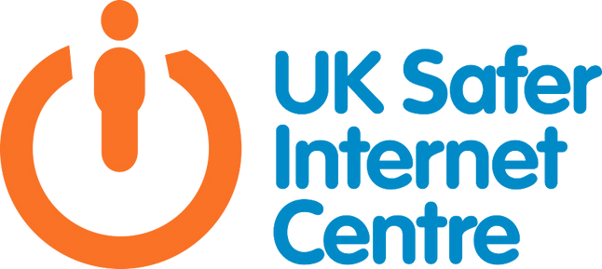

This is to certify that

Supports

Safer Internet Day 2022

**#SaferInternetDay**

8th February 2022

**saferinternetday.org.uk**