NEWS FROM THE FEDERATION CHARITY FUND – FEBRUARY 2022

A brief update on the Federation Charity Fund as are now we move in to the Spring and Summer of 2022 with covid-19 virus restrictions now disappearing but with the virus still causing an impact!

Over the last year both Federation schools have been making detailed and extensive adjustments to keep pupils and staff safe from the Covid-19 virus and have provided home learning opportunities for those who were not able to come into school. Now that children have returned to school they are still be vigilant to ensure are kept safe.

What has happened over the last year?

We have recently published our latest Annual Report (2020/21). This can be seen on our Facebook page or on the Federation Website Charity Page - details below.

2021 was, unfortunately, a second year of consolidation largely forced upon us by Covid-19 and the fact that many of the bodies from whom funding would be available had significantly reduced their activities. We were fortunate that QEII was able to benefit from the generosity of Tesco in funding through their Bags of Help scheme some special scooters to encourage greater mobility around the school and widen play options. These came into use last term and are greatly appreciated! THANK YOU TESCO!

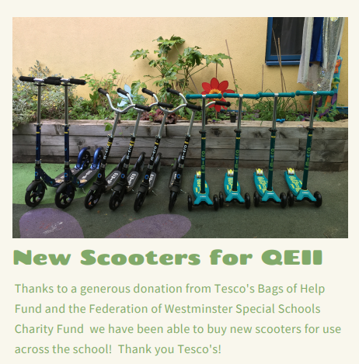
We are currently focussing on attempting to obtain funding for new minibuses for College Park and QEII – hopefully we will have some good news in the near future.

What can YOU do to help (at no cost to you!!).

Amazon

Just a reminder that we have registered the Charity Fund with Amazon and their SmileAmazon charity organisation. This gives the Charity Fund 0.5% of the net purchase price (i.e excluding VAT and any postage).

How to sign up
- If you are a regular Amazon customer at present you will frequently see a “pop up” alerting you to the SmileAmazon option.
- “Accept” this and it will ask you to choose a charity (you only need to do this once – it remembers) you will find Federation of Westminster Special Schools Charity Fund in the drop down listing and select this
- If you do not get the “pop up” just google SmileAmazon.co.uk and it will take you into your account with the charity options above. It will remain and as long as you log in as SmileAmazon.co.uk. There will be a link on the charity Facebook page (see below).

Although the above will only raise small amounts for the Charity Fund each time they are used, if you spread the word to other family members and friends this site will keep giving more.

Keep up to date

Visit the Federation Website - Charity Fund Page at

www.qe2cp.westminster.sch.uk

Visit our Facebook page at

Federation of Westminster Special Schools Charity Fund

If this update has inspired you to donate please do not be shy – here is how you do it -

Donations can be made in two ways

By bank transfer to sort code 40 52 40 Account number 00032025. (Please put in a reference to identify your donation)

By cheque made payable to FWSS Charity Fund and sent to the address below

Federation of Westminster Special Schools Charity Fund
C/o College Park School, Garway Road, London, W2 4PH
Email: charity@qe2cp.westminster.sch.uk
Charity No. 1173810

