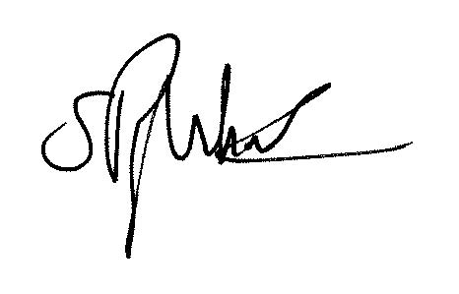

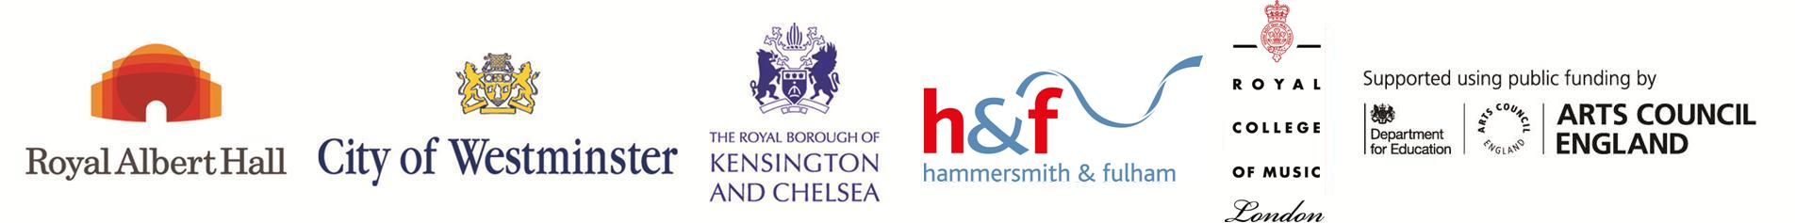

Certificate of
2020-2021

SILVER SCHOOL MEMBERSHIP

College Park School

We are members of the Tri-borough Music Hub,
committed to a broad and balanced curriculum.

Stuart Whatmore
Head of Tri-borough Music Hub

