Dear Parents/Carers
We would like to invite you to our Coffee Morning

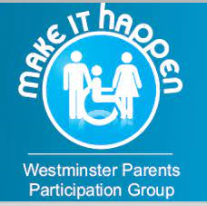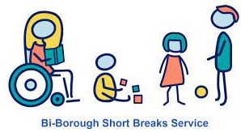

Date: Thursday 26th May
Time: 10am – 11:15am
At: College Park School

We invite you to join us to meet Laura Dullaway - Service Navigator
Bi-Borough Disabled Children’s Support Service who will be sharing information about the services and support available to families.

We are pleased to also welcome Hend Rahman from Make it Happen – Westminster Parents Participation Group, who will also be able to share information about support available and news on up and coming events.

Please do come and join us to find out more information.

Everyone welcome and we look forward to seeing you!



