Dear Parents/Carers
We would like to invite you to our Coffee Morning

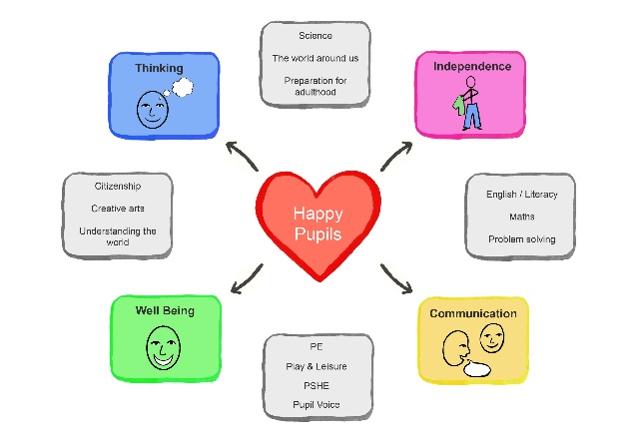
Date: Thursday 12th October 2023
Time: 10am – 11:15am
At: College Park @ Bayswater
Theme: Our Curriculum
We invite you to join us to discuss our school curriculum. We will be presenting our school offer and explain how our aim is to champion the right of each learner to access a personalised, ambitious and meaningful curriculum.

We value the relationships created between families and ourselves, and advocate for a strong and open dialogue.

All welcome and we look forward to seeing you! 

